**Aim:** Write a Python function **countX(lst, x)** to count the number x in a given list of numbers.

**PROGRAM:**

def countX(list,s):

c=0

for i in range(0,len(list)):

if(list[i]==s):

c+=1

print(c)

list=[]

x=int(input())

for i in range(0,x):

list.append(int(input()))

s=int(input())

countX(list,s)

**LINK:** [**http://103.53.53.18/mod/vpl/view.php?id=230**](http://103.53.53.18/mod/vpl/view.php?id=230)

**OUTPUT:**

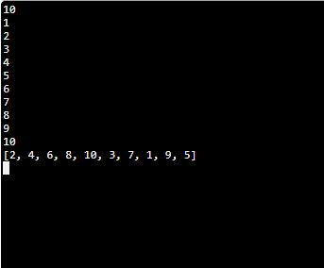

**RESULT:** Thus the python program is written and count the number x in given list of number is calculated and printed